- INTRODUCTION

This project focuses on the Analysis of Job Postings Years of Experience and programming Language Requirements.
The data used includes Minimum Years Experience, Median Salary Estimate in USD, and Data Languages.
The project aims to compare salary ranges across different technical skill requirements.

- Scatter Plot: Minimum Years Experience Vs Median Salary.
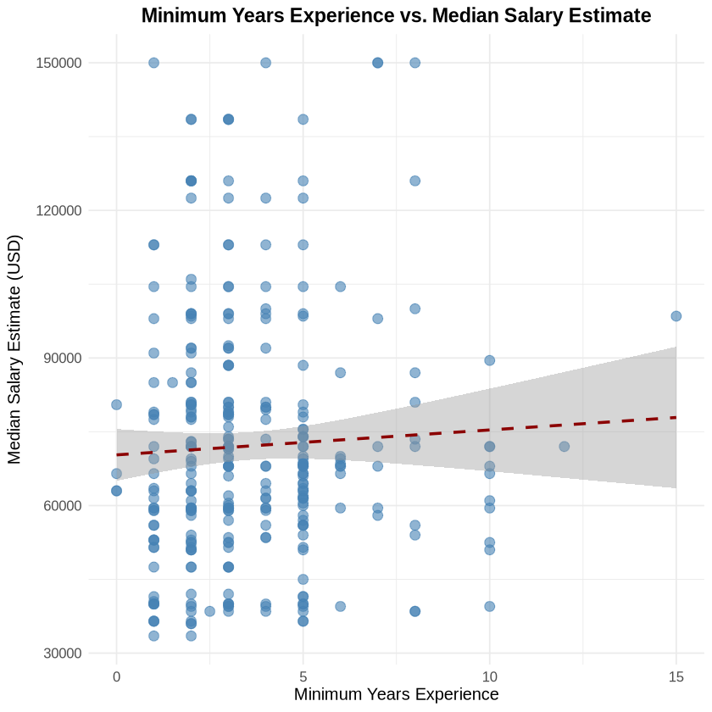
This Scatter plot shows the relationship between minimum years of experience required and median salary estimates. The dashed red line shows trend
- Box Plot: Median Salary Estimate by Data Languages.

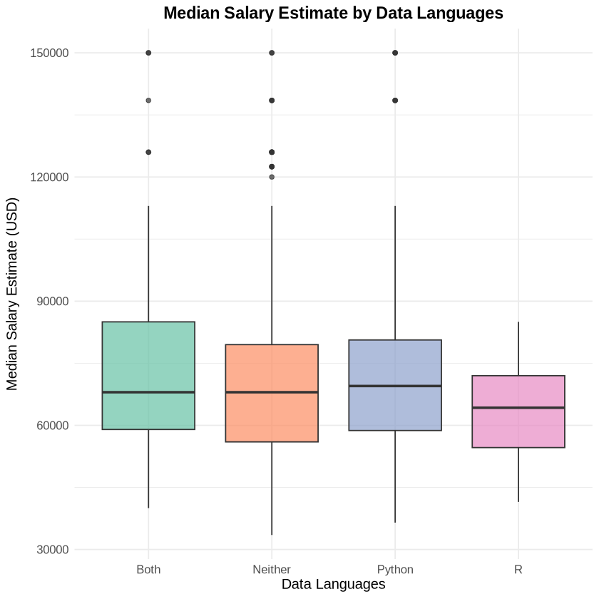
This box plot compares salary distributions across the four data language categories:
- Both (R and Python): 65 positions
- Neither: 256 positions
- Python: 64 positions
- R: 14 positions
The box plots show the median, quartiles, and outliers for each category, making it easy to compare salary ranges across different technical skill requirements.
- Reflection.
LLM understands context to accurately distinguish data.
What was difficult is the coding knowledge.
I learnt a more presentable method of Data Analysis,

